***1. Identify (at least 2) types of users of the system.***

Customers, owners analysing buying patterns, the sales team updating product information and the warehouse team updating stock information.

***2. Are there other stakeholders than the users?***

The webshop maintenance team. The owners and the webshop employees who use the system.

***3. Draw use case diagrams for the webshop.***

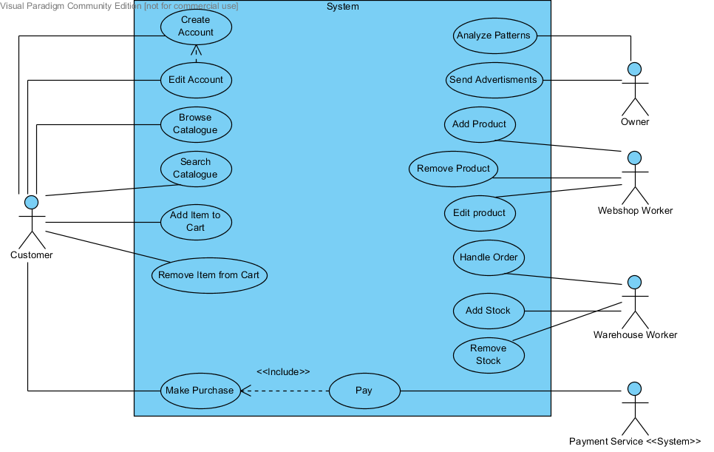

***4. Identify which groups of use cases relate to the same area of functionality (e.g. the functionalities logically belong together or operate on the same data).***

* Create account, Edit account, Add item to cart, Remove item from cart.
* Add product, Edit product, Delete product, Add stock, Remove stock
* Browse catalogue, Search catalogue
* Analyze patterns
* Send advertisements
* Handle order, Make Purchase, Pay

***5. Identify the subsystems/components in the architecture of the webshop system.***

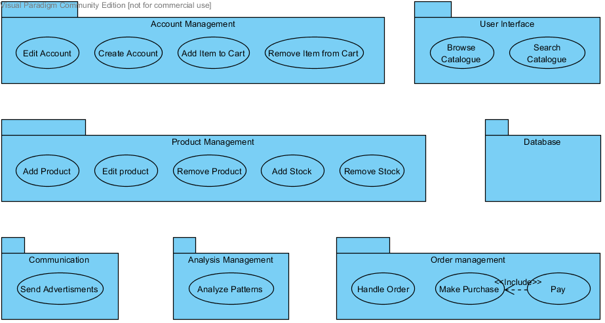

***6. Describe the responsibility of each component using at most a single sentence.***

*Analysis Management:* Analyses buying data.

*Communication:* Sends advertisement information to customers.

*User Interface:* Handles the display of data to the users and helps them locating products.

*Product Management:* Handles the management of products and stock. When adding, editing or removing products as well as increasing or decreasing their stock it’s handled by the product management.

*Account Management:* Handles the management of accounts such as creating new ones or editing existing accounts.

*Order management:* Handles payment and communication with online bank interface.

Database: Stores data.

***7. Provide a structural view of the architecture of the system that uses the layering as shown in*** ***(the right of) Figure 1. You should allocate all the components that you identified in question 5 to the layers of the architecture. You may omit the business-logic layer if you prefer.***

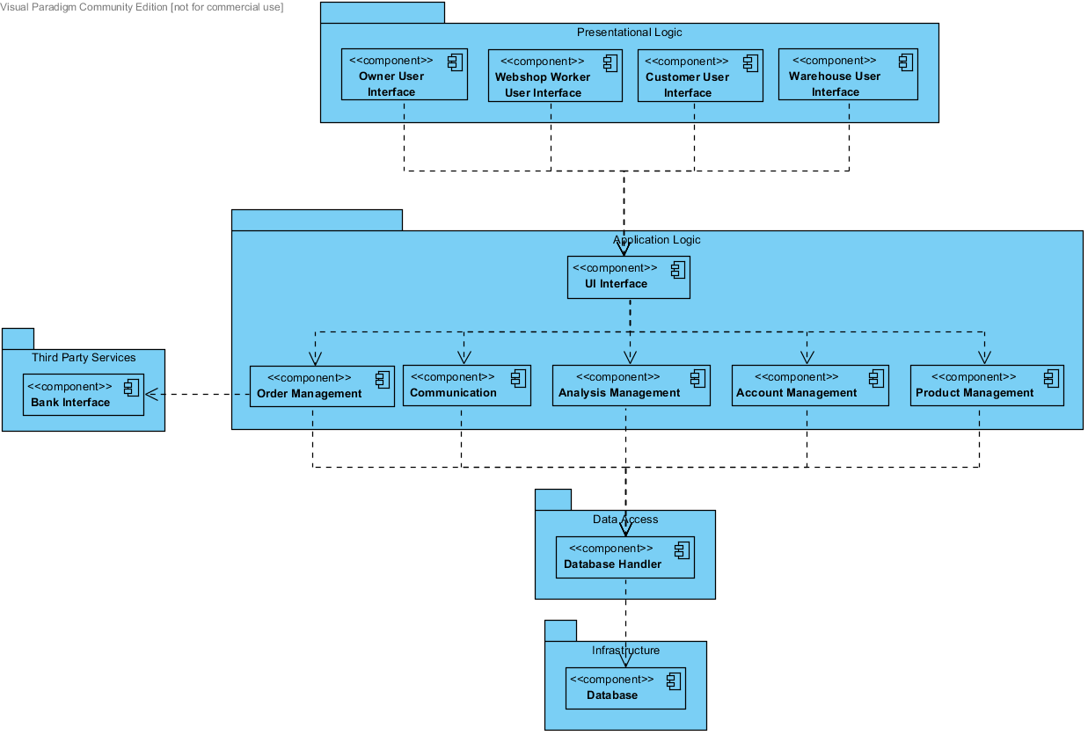

***8. Illustrate the interaction of the components by illustrating 3 key use cases by means of sequence diagrams***.

*Remove Item from Cart*

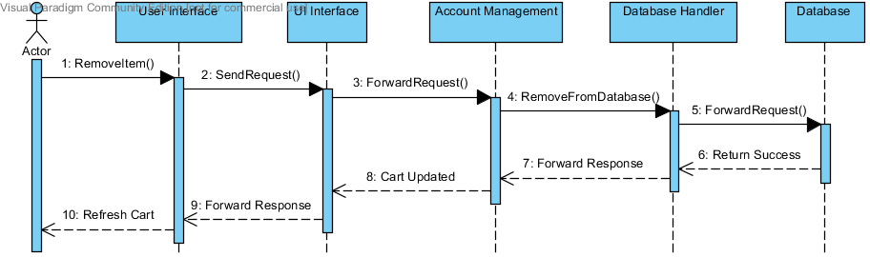

*Add Stock*

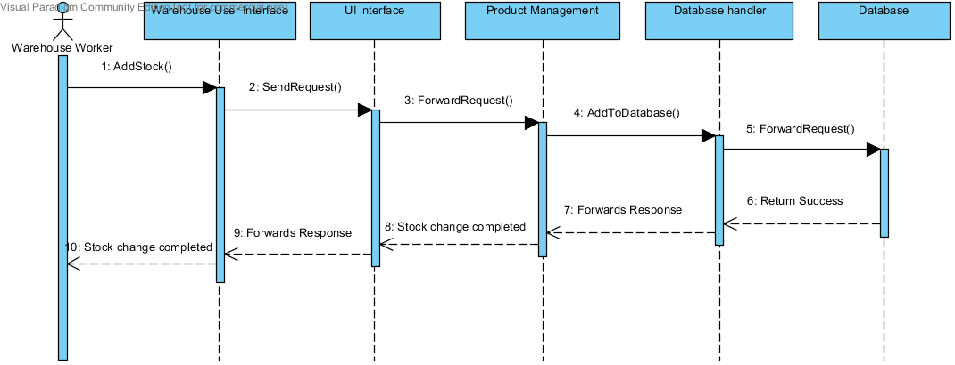

*Send Advertisement*

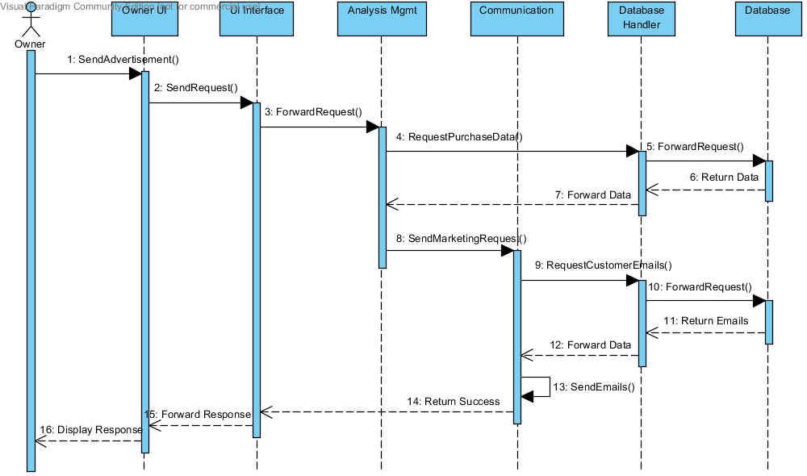

***9. Which architectural style does your system use? Why?***

The system uses a Client-Server architectural style. The clients are the customers using the webshop and the employees maintaining it. Users send requests to the server, such as add item to shopping-cart or increase stock of product, and the server carries out the request to generate a result and return it to the user. This style provide high control and security, since all data stored on the server.

***10. Discuss the deployment relationships between the elements of the architectural style you selected and the layers shown in (the right of) Figure 1.***

Since the system is client-server with a layered structure. The presentational layer is run on the client computer, while all the other layers run on the server. This means all computation is done on the server, and the result is then displayed to the client running the user interface.